C64 Promenade Model D Rev. 0

Module Description

The Promenade Model D is an EPROM programmer for the Commodore C64. The Model C is originally created by Jason-Ranheim in the 1980s. Model D is a remake of it, the layout and geometry is changed, though. The blocking of the tape port is fixed. Further, some 100n bypass capacitors were added.

This project was executed in cooperation with Greg Nacu (c64os.com). He asked me for making a layout for it. Greg has built and tested it, AFAIK with many but not all EPROM types listed.

For the documentation, please consult this website: <http://c64os.com/post/promenadec1>

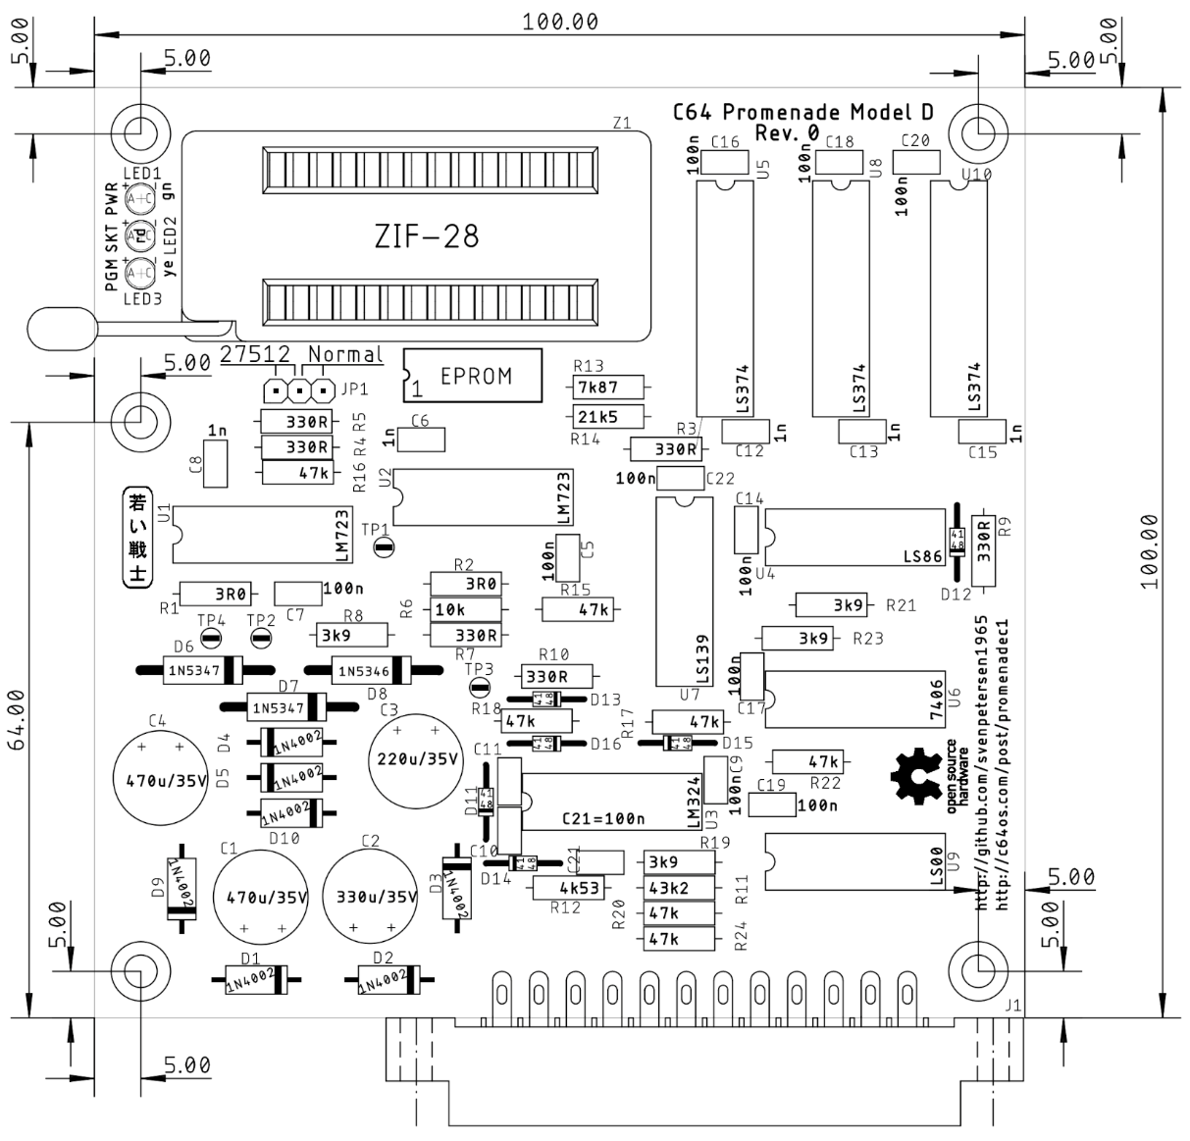

Figure 1: Dimensions of the Promenade Model D

This project is provided “as is”. I own a prototype, which was provided by Greg.